SCOREKEEPING RESPONSIBILITIES

HOW TO FIND VIDEOS ABOUT SCOREKEEPING

STEP 1: Go to https://www.fdlittleleague.com/

STEP 2: Scroll down the website & click on Helpful Links on the right side.

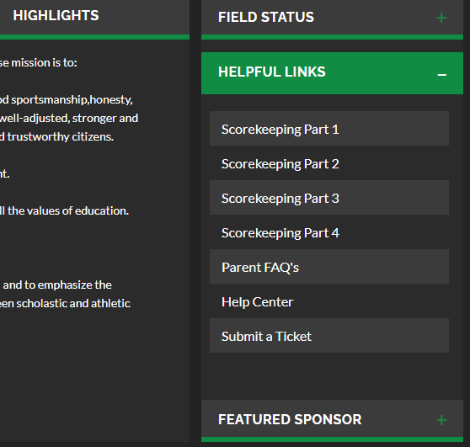

STEP 3: Review each video

-The coach will have the scorekeeping sheets

